Total Group of Companies commit to encouraging biodiversity at its sites wherever possible.
TGC’s objectives under this policy are the following:
- Maximise biodiversity at its sites
- Ensure that current biodiversity is maintained and that it is not lost through TGC activities.
- To be site stewards to ensure a sustainable future

To achieve these objectives TGC has committed to:
    - Increasing flora wherever possible on sites.
    - Creating a habitat for flora and fauna which allows them to thrive. This policy shall apply to all business units, employees, and contractors in service to our business.
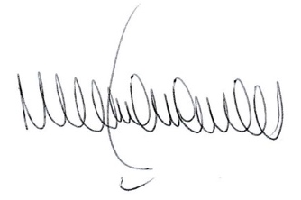 Matthew Hague
CEO

